Activity Level is not validating the data – I was able to insert the same record twice
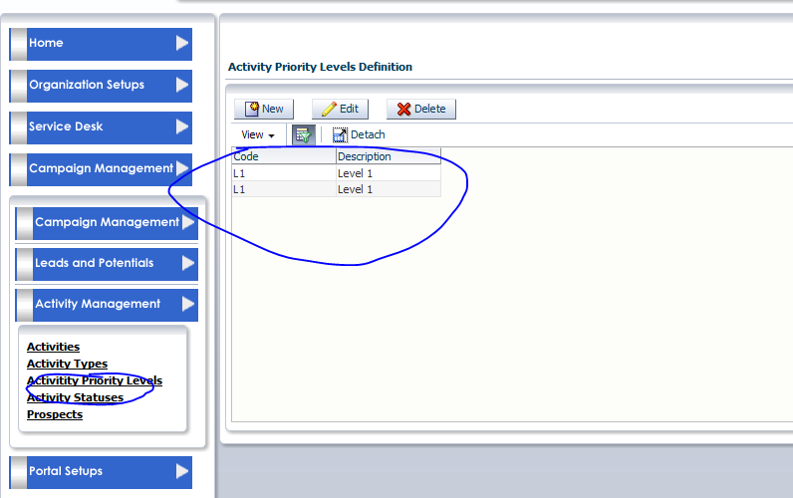

Activity Status is not validating the records – I was able to duplicate the same status twice
